Can I Get an Ultrasound Without a Referral? - Insights from Crystal Radiology in Auburn. (02) 8315 8292

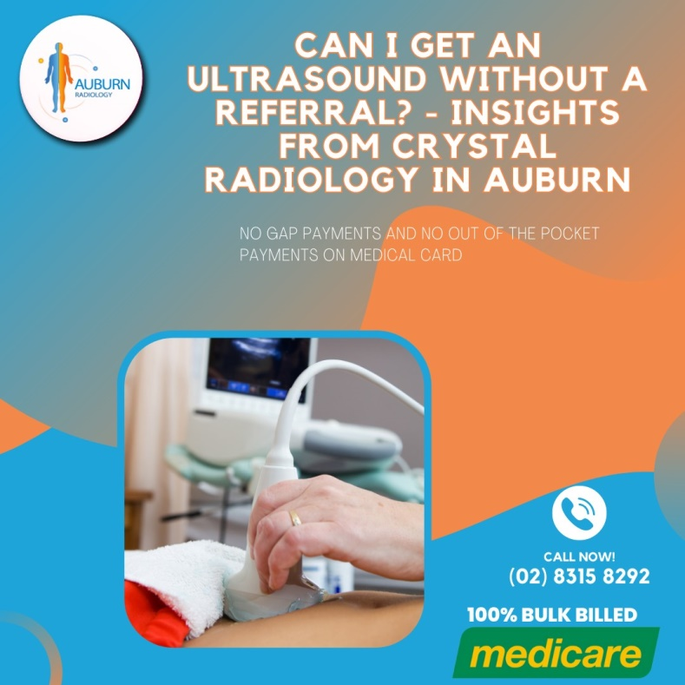**The Role of Ultrasound in Diagnostic Imaging**

Ultrasound is an essential and versatile imaging tool in modern medicine, offering a non-invasive way for doctors to see inside the body without the need for surgery. By utilizing high-frequency sound waves, [ultrasound](https://crystalradiology.com.au/ultrasound/) creates real-time images of organs, tissues, and other internal structures, making it an invaluable resource for diagnosing a wide range of medical conditions. From abdominal pain to joint issues and monitoring pregnancies, ultrasound is a safe, relatively inexpensive, and effective diagnostic tool that provides instant results. Here's why ultrasound has become such an important part of diagnostic imaging.

**How Ultrasound Works**

Ultrasound technology operates by sending high-frequency sound waves into the body using a transducer. These sound waves bounce off [internal structures](https://crystalradiology.com.au/ultrasound/), and the echoes are then captured and converted into images on a monitor. This process allows healthcare professionals to observe various parts of the body in real-time, providing a detailed view of the organs, tissues, and blood flow.

One of the most common uses of ultrasound is during pregnancy, where it is employed to monitor the growth and development of the fetus. It can also detect abnormalities early on, allowing for timely intervention if necessary. Beyond pregnancy, ultrasound is used to examine the heart, blood vessels, liver, kidneys, and other organs, as well as muscles, joints, and soft tissues, making it a versatile tool in diagnostic imaging.

**The Referral Process for Ultrasound**

If you're wondering whether you need a referral to get an ultrasound, the answer is typically yes. In most cases, a referral from a doctor or healthcare provider is required to undergo an ultrasound. Here's a step-by-step guide on how the referral process works:

**Step 1: Talk to Your Doctor**

The first step is to schedule an appointment with your healthcare provider. This could be your primary care physician, a specialist, or your midwife if you're pregnant. During the consultation, your doctor will discuss your symptoms, perform a [physical examination](https://crystalradiology.com.au/ultrasound/), and determine if an ultrasound is necessary for diagnosing or treating your condition. Ultrasounds are often ordered to investigate issues like abdominal pain, abnormal bleeding, or to monitor the progression of a disease.

**Step 2: Get the Referral**

If your doctor decides that an ultrasound is medically necessary, they will provide you with a referral. This referral acts as a detailed note to the radiologist, specifying the type of ultrasound required, the reason for the procedure, and any pertinent medical history. The referral is crucial as it ensures the radiologist has all the information needed to accurately interpret the ultrasound images and make a correct diagnosis.

**Step 3: Schedule the Ultrasound**

With the referral in hand, you're ready to schedule your ultrasound. You can contact an imaging center or hospital, like [Crystal Radiology](https://crystalradiology.com.au/ultrasound/) in Auburn, to arrange the appointment. Typically, the referral will already be sent over by your doctor’s office, simplifying the scheduling process.

**Exceptions to Needing a Referral**

While a referral is generally required, there are a few exceptions where you might not need one:

1. **Non-Medical Ultrasounds:** Some imaging centers offer ultrasounds for non-medical purposes, such as 3D or 4D images of your baby during pregnancy. These "fun" ultrasounds are meant for keepsakes rather than medical diagnostics, and usually don't require a referral.
2. **Direct Access to Midwives:** In certain regions, you may be able to see a midwife directly for pregnancy care, and they can order ultrasounds without needing a referral from a physician. However, the availability of this option depends on local regulations, so it’s important to check the rules in your area.

**How Crystal Radiology Makes Ultrasounds Easy?**

At Crystal Radiology in Auburn, we strive to make the ultrasound process as convenient and comfortable as possible. We understand that medical appointments can be stressful, so our team is dedicated to providing a welcoming and supportive environment. Our skilled ultrasound technicians work closely with your [doctor](https://crystalradiology.com.au/ultrasound/) to ensure that you receive the highest standard of care and accurate results.

In addition to our state-of-the-art facilities, we offer flexible scheduling to accommodate your needs. Whether you require a routine ultrasound or a more specialized exam, Crystal Radiology is here to help. We pride ourselves on delivering quick, reliable results that help your healthcare provider make informed decisions about your care.

**Why Choose Crystal Radiology?**

We are local and a privately-owned medical clinics that offers the highest quality medical and Imaging Services in the Crystal radiology region. We are the leaders in [Bulk Billing](https://crystalradiology.com.au/appointment/) with the real benefit of no ‘Out of Pocket’ expenses for you.

**Your Next Step**

Please ensure that you have your Medicare card and referral with you and pop into our location for your consultation. If you have any questions at all, please feel free to contact us at [(02) 8315 8292](https://crystalradiology.com.au/appointment/) as we are here to help.